University of Winnipeg
Emotion classification in text using Machine Learning approach
Advanced Machine Learning (7401-002)
Submitted To: Prof Sheela Ramanna

Submitted By: Srinivas Kasturi
(3078674)
Date: 4/11/2017

Recognizing emotions in text using Machine Learning approach.
Srinivas Kasturi
University of Winnipeg, Winnipeg, MB, CANADA
Kasturi-s@webmail.uwinnipeg.ca
Abstract. Emotions are the key elements in the human behavior and nature. Humans express their emotions in the most common way by expressing their thoughts, opinions. This project addresses the problem of emotion analysis in given sentences; that is by classifying sentences/text messages according to the emotion expressed in them. The process of analyzing the public sentiment is more important for many applications such as stock market, trading business, elections. Over the last few years, there is a tremendous increase in the research operations which are related to human emotions. The main part of this project is the implementation of the ensemble classifier which mainly consists of three machine learning methods such as Naïve Bayes (NB), Maximum Entropy (MAXENT) and Support Vector Machine (SVM). In this study, classification of positive and negative emotions in the text has been studied using Yelp dataset. In this paper, we present a sentiment analysis application for automatic recognition of emotions in text, using a classifier which is quite similar to an ensemble of classifiers. This classifier is aimed at some of the segregated data sets which were obtained from online providers. The experimental results give quite satisfactory performance regarding the ability to recognize/detect the emotion presence in text and also to identify the polarity.
Keywords: Emotion Classification, Ensemble Classifier, Maximum entropy, Naïve Bayes, Support vector machine.
- Introduction
  - Motivation
Emotions constitute a key factor in the intelligent behavior of humans. The role of emotion analysis was recognized as the part of affective computing. We have chosen to work with text emotion analysis since we feel it is a better approximation of public sentiment as a part by considering social networking applications. The reason is that the amount of relevant data is much larger on Facebook, twitter, as compared to other traditional blogging sites. Moreover, the response of texts on social networking sites is more prompt and also more general. Over last years the raising of the social media had changed the entire mode of human life. Analyzing the texts and web content with the aim to recognize their emotion is a challenging task. The analysis of this particular textual data may provide his emotion towards a particular topic, city or even a person. Let us consider a global firm, by analyzing overall public emotion towards that particular firm with respect to time and using economics tools we can predict the stock market value of that firm. Firms can also estimate how well their products craze in the market, which areas of the market is it having a favorable response and in which a negative response (since geo -tagged texts allows us to point to particular locations). This type of intelligent business is happening now a days around us. Emotional analysis also plays a crucial role in predicting the results of popular political elections (ex. USA Exit poll).
This process of analyzing emotions of texts comes under the domain of “Pattern Classification” and “Data Mining”. Both of these terms are very closely related to each other and they can be formally defined as the process of discovering patterns in a large set of data, either automatically (unsupervised) or semi- automatically (supervised). The project would depend upon the techniques of “Natural Language Processing” in extracting significant patterns and features from the large dataset of tweets and on “Machine Learning” techniques for accurately classifying individual unlabeled data samples such as text messages.
Language based features are those that deal with a formal theme and include a prior emotional polarity of individual words and phrases, and parts of speech and tagging of the sentence. Prior sentiment polarity means that some words and phrases have a natural innate tendency for expressing particular and specific sentiments in general. For example, the word “love” has a strong positive connotation while the word “hate” possesses a strong negative connotation. So whenever a word with a positive connotation is used in a sentence, chances are that the entire sentence would be expressing a positive sentiment. Also, the pointed sentiment and emotion recognition approach should tend towards the content and context of the natural language. It means to automatically identify which part of speech each individual word of a sentence belongs to different kinds of parts of speech. Patterns can be extracted from analyzing the frequency distribution of these parts of speech (either individually or collectively with some other part of speech) in a particular class of labeled texts.

1.2 Outcome
In this project, we implement the ensemble classifier for the sentiment analysis of textual data. This classifier implementation is aimed to overcome the basic drawbacks. This system is based on mainly three types of the statistic learners such as naive Bayes learner, maximum entropy learner and support vector machine learner. This three learners association is formed by using the NL (natural language) Toolkit. This ensemble classifier initially splits the sentences and these sentences were fed to the main ensemble classifier where the features of those sentences were extracted and represented as the BOW (bag-of-words) and then handled by the statistical learners. After the above process, the classifiers such as Naïve Bayes (NB), Maximum Entropy (MAXENT) and Support Vector Machine (SVM) will determine the emotional polarity. There are several methods for proposed for computing and comparing the results of our experiments. Some of the most popular metrics include Precision, Recall, Accuracy, and F-measure (each of these metrics is calculated individually for each class and then averaged for the overall classifier). These metrics are discussed briefly below.

- Background
Sentiment analysis and classification are mainly based on the machine learning approaches which were widely used in automatic recognition of emotions in texts. In general machine learning approach utilizes its algorithms to train learners for extraction of the emotional features. This classifier mainly uses the annotated corpus (It can also be provided with additional linguistic information, called 'annotation') for the purpose of training the learners. On the other hand there learners use the ‘Natural language tool kit’ to perform these operations and on bag-of-words to get extraction features. The bag-of-words model is one of the widely used feature model for all text classification tasks due to its simple and good performance. Sentiment analysis is being used by various researchers till now. The simplest way to develop this model in ensemble classifier is by using unigrams as features. In general n-grams is a stream sequence of “n” words in our text data, which is completely independent of any other words or grams in the text. Unigrams/Bigrams is just a collection of individual words in the text which are to be classified, and we assume that the probability of occurrence of one word should not be affected by the occurrence or absence of any other word in the text. The simple way to use unigram is by assigning them with a polarity and then considering the average polarity, for example word like “awesome” would probably have strong subjective polarity along with positivity, while the word “nice” would have positive polarity but with weak subjective. They say that the prior polarity of a word may in fact be different from the way the word has been used in the particular context
Besides from these, a large amount of work was done on exploring the classification of features into different kind of domains. The simplest way of incorporating this model in our classifier is by adding the unigrams feature. N-grams is a continuous sequence of the words in the stream, where it is completely independent on all the other kinds of words. Here we use unigram in which only the related or useful words were considered for classification. One simple way to use unigrams as features is to assign them with a certain prior polarity, and take the average of the overall polarity of the text [4] & [1].
The basic problem with the approach of prior polarity approach has been identified by Wilson et al. who distinguish between prior polarity and contextual polarity [1].

  - Related Works
Now a days recognizing emotions and analyzing human behavior have attracted the attention of researchers in computer science, natural language processing and sentiment analysis. Several research works study the way human express emotions and how they try to specify their emotions in news, web blogs, forums and social media (Thelwall et al., 2012; Cambria et al., 2013; Liu, 2015)[1]. Wide range of activities that performed to recognize the emotions were mainly targeted by using the machine learning approach. Alm, C.O., Roth, D., Sproat, R., 2005 was the finest team to conduct their experiments on this approach. They designed their classifier in such a way that it can classify sentences of fairy tales automatically, but they are manually annotated with emotional information. Finally their results satisfied them with satisfactory results according to ekmans emotion.
The work displayed in Neviarouskaya et al. (2007) intends to perceive Ekman’s six fundamental feelings in online blog entries. The creators examine the posts utilizing Machines Syntax parser, spot emoticons and watchwords that may show up in the posts and utilize a govern based way to deal with decide sentence passionate substance. This framework created reports roughly 70% concurrence with human annotators in acknowledgment of passionate substance of sentences [1].

In the work exhibited by in Danisman and Alpkocak (2008), makers demonstrate an approach in light of vector space model to mastermind energetic substance. They use the ISEAR (International Survey on Emotion Antecedents and Reaction) and the SemEval datasets what's more, the gathering, which focuses on the request of sentiments what's more, valence in substance is made in perspective of vector space appear on a total of 801 news highlights gave by the Affective Task of SemEval 2007. Makers report that the vector space indicate portrayal model can give favored execution happens over different classifiers including Concept Net, Naïve Bayes, and reinforce vector machines [1].
In Osherenko and André (2007), a measurable approach for influence detecting in printed information is exhibited. Creators address the printed influence acknowledgment errand for unconstrained expressions in view of emotional characteristics of words and characterize feelings by utilizing word checks. In their analyses, they consider full of feeling word references and universally useful lexical assets what's more, show that viable explanations appear to give a decent intends to diminish the quantity of components for passionate arrangement[4].
The ensemble classifier approaches in the literature mainly rely on sole machine learning classifiers. However, the machine learning approaches in general ignore semantic and syntactic features of the analysis of the sentences, something that made them non-context sensitive. On the other employee, the classification methods based only on keywords can survive from the duplicity in the keyword definitions in the sense that a word can have different meanings according to its set and context and also the incapability of recognizing emotions within sentences that do not contain burning keywords (Shaheen et al., 2014)[1]. So, based on the before, an generally classifier behave that would combine both equipment learning and knowledge-based approaches could be of great interest. In addition, our work presented in this paper is, to the best of our knowledge, one of the first approaches in the sentiment analysis domain to examine this direction.
There has additionally been extremely late research of grouping tweets as indicated by the mood expressed in them, which goes above and beyond. ‘Bollen et al. investigates this range and builds up a system to arrange tweets into six moods: tension, depression, anger, fatigue and confusion [4]. They use an extended version of Profile of Mood States (POMS): a broadly acknowledged psychometric instrument. They produce a word lexicon and dole out them weights comparing to each of the six inclination states, and after that they spoke to each tweet as a vector relating to these six measurements. However very little detail has been given into how they assembled their modified vocabulary and what method did they use for order.
Big data can also be used for some application and for that the analysis done is called Sentiment Analysis. But analyzing this large dataset is not so easy, and same way Sentiment Analysis is lacking for Negation Statement case. This problem is reducing the accuracy of Sentiment Analysis was proposed by the Sakshi Saxena & Toran Verma [2].
- Theoretical Framework
  - Machine Learning Algorithm
Machine learning algorithm mainly divided into two parts i.e. Supervised Approach and Unsupervised Approach. Machine learning based approach uses classification technique to classify text into classes. There are mainly two types of machine learning techniques
The most commonly used features in sentiment classification are
Unsupervised learning:
It does not consist of a category and they do not provide with the correct targets at all and therefore rely on clustering.
Supervised learning:
It is based on labeled dataset and thus the labels are provided to the model during the process. These labeled dataset are trained to get meaningful outputs when encountered during decision-making.
The success of both this learning methods is mainly depends on the selection and extraction of the specific set of features used to detect sentiment. The machine learning approach applicable to sentiment analysis mainly belongs to supervised classification. In a machine learning techniques, two sets of data are needed:
1. Training Set
2. Test Set.
A number of machine learning techniques have been formulated to classify the texts into classes. Machine learning techniques like Naive Bayes (NB), maximum entropy (MAXENT), and support vector machines (SVM) have achieved great success in sentiment analysis.
Machine learning starts with collecting training dataset and after this we train a classifier on the training data. Once a supervised classification technique is selected, an important decision to make is to select feature. They can tell us how documents are represented.
  - Natural Language Processing
Natural language processing (NLP) is the ability of a computer program to understand human speech as it is spoken. NLP [2] is a component of artificial intelligence (AI). Today NLP is a necessary tool since human has to communicate to the computers and computer understand only machine language for that naturally converting processing is required. Current approaches of Natural Language Processing is through the use of Machine Learning Algorithm .NLP can mainly performs various functions shown in Fig 1.
There are various NLP toolkits available like Stanford NLP, Natural Language Toolkit (NLTK), Apache OpenNLP, Apache Lucene & Solr. For this paper the Natural Language Toolkit (NLTK) have been considered better which is open source with the use of Maximum Entropy, Naïve Bayes, and Support Vector Machine algorithms as the Machine Learning Algorithm [2].

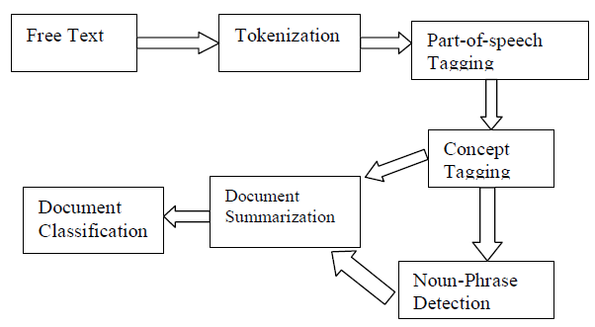
Fig. 1. Natural Language Toolkit functionality [2].

  - Emotion recognition system
This classifier was developed by using the NLTK (natural language toolkit) to recognize the emotions which are present in the given texts. The analysis of the natural language toolkit goes from the basic level of the sentence. The document is split into sentences. Now the system approaches to get a fine and clear view of the sentences to get the expressed sentiment in the document without considering the author’s feelings. On coming to the ensemble, we have used mainly three types of the classifiers. These classifiers are based on the statistical approach. Naïve Bayes and Maximum entropy algorithm and SVM were trained to extract the emotions in texts. The learners were trained using the YELP and ISEAR datasets. Natural Language tool kit performs the deep analysis of the sentences in the documents and considering the word dependencies and it will convey how the words are connected to each other to give a specific emotion as an output. In this ensemble method the sentence’s structure is analyzed using the NLTK tool. The architecture of the above classifier is explained in FIG-2[1].
This combinational ensemble connects all the three and gives the combinational output. This system will be given a text document where each sentence is analyzed and then it’ll determine it as an emotional or neutral basing on the contextual polarity of the text.

Fig. 2. Ensemble Classifier flow [1]
  - Feature representation & extraction

`In this representation of natural language we use BOW (bag of words) technique. BOW is very simple and easy to embed in our current process. This BOW will be performing the stop word functionality which is nothing but removal of the unwanted words and stemming the useful words. In this process the text or sentence may shuffle in the case of word positions. But still BOW doesn’t consider the value of the positions and it will filter out the sentences stop words and forwards the sentences features to the learners [1].
  - Maximum Entropy

The Max Entropy classifier is a probabilistic classifier which belongs to the class of exponential models. Max Entropy does not assume that the features are conditionally independent of each other. The MaxEnt is based on the Principle of Maximum Entropy and from all the models that fit our training data, selects the one which has the largest entropy. The Max Entropy classifier can be used to solve a large variety of text classification problems such as language detection, topic classification, sentiment analysis and more [2].
The mathematical formula for Entropy is given by

$H\left(p\right)=-\sum{p(a,b) log p(a,b)}$ (1)

Our target is to use the contextual information of the document (unigrams, bigrams, other characteristics within the text) in order to categorize it to a given class (positive/ negative etc.). Maximum Entropy main Principle is Higher the entropy higher is the uniformity. The maximum entropy principle is based on selecting the most uniform distribution which is to be known by the one having maximum entropy. To define Log Likelihood of the model p with respect to the empirical distribution p, which is derived below in the formulae:-

$Lp'(P)=\log{\prod_{x∈X}^{n}{{p\left(x\right)}^{p^{'}\left(x\right)}}}=\sum_{x∈X}{p^{'}\left(x\right)logp(x)}$ (2)

  - Support Vector Machine

Support vector machines are universal learners [2]. The main property of SVM is that their ability to learn can be independent of dimensionality of feature space. SVM has defined input and output format. Input is a vector space and output is 0 or 1 (positive/negative). Text document in original form are not suitable for learning. They are transformed into format which matches into input of machine learning algorithm input. For this preprocessing on text documents is carried out, then we carryout transformation. Each word will correspond to one dimension and identical words to same dimension. As mentioned before we will see TF-IDF for this purpose. Now a machine learning algorithm is used for learning how to classify documents, i.e. creating a model for input-output mappings. SVM has been proved one of the powerful learning algorithm for text categorization [2].Support vector machine analyzes the data, define the decision boundaries and uses the kernels for computation which are performed in input space. The input data are two sets of vectors of size m each. Then every data which represented as a vector is classified into a class. Next we find a margin between the two classes that is far from any document. The distance defines the margin of the classifier, maximizing the margin reduces indecisive decisions. SVM also supports classification and regression which are useful for statistical learning theory and it also helps recognizing the factors precisely, that needs to be taken into account, to understand it successfully.
  - Naive Bayes

Naive Bayes is a simple model for classification and can achieve good performance in text categorization. It is based on Bayes theorem and is a probability based classification approach that assumes that documented words are generated through a probability approach. In general, the lexical units of a corpus are labeled with a particular category set and then they are processed computationally. During this processing, each document is treated as a bag-of-words, so the document is assumed to have no internal structure, and no relationships between the words exist. A universal feature of Naïve Bayes classification is the conditional independence assumption. Naïve Bayes assumes that words are mutually independent and so, each individual word is assumed to be an indication of the assigned emotion [1]. The Bayesian formula calculates the probability of a defined class, based on document's features and is calculated as:

$P\left(c|s\right)=(P\left(c\right)P\left(s | c\right))/P(S)$ (3)

Where P(c) is the probability that a sentence belongs to category c, P(s) is the probability of sentence s occurrence, P(s|c) is the probability that the sentence s belongs to category c and P(c|s) is the probability that given the sentence s it belongs to category c[1]. The term P(s|c) can be computed taking into consideration the conditional probabilities of occurrences of sentence's words given the category c, as follows:

$P\left(s|c\right)= \prod_{1≤k≤n}{P\left(Sk\left(c\right)\right)}$ (4)

Where P(s_{k}|c) represents the probability that term (word) s_{k} occurs given the category c and n represents the length of sentences[1].

  - Specify emotional polarity:

The emotional polarity concept was characterized by the "Russell" in 1980. Feelings can be spoken to in the multidimensional, one measurement will speak to the extremity and the other will speak to initiation. Extremity can characterize the feeling as a positive or negative. The initiation and the extremity ideas are commonly mapped basing upon the enthusiastic substance of the framework. Give us a chance to consider the feeling "bliss" despite the fact that it is a positive feeling while the outrage, sicken and dread may choose the sentence as negative. For this situation framework will get the passionate mapping and it depends on it to indicate the extremity of the
Sentence. Fig.3 gives the polarity modes of the texts [1].
  - Metrics Computation
There are several metrics proposed for computing and comparing the results of our experiments. Some of the most popular metrics include: Precision, Recall, Accuracy, F1-measure (each of these metrics is calculated individually for each class and then averaged for the overall classifier performance.) A typical confusion table for our problem is given below along with illustration of how to compute our required metric.

Fig. 3. Polarity mode [1]

True positives (TP), true negatives (TN), false positives (FP), and false negatives (FN), are the four different possible outcomes of a single prediction for a two-class case with classes “1” (“yes”) and “0” (“no”). A false positive is when the outcome is incorrectly classified as “yes” (or “positive”), when it is in fact “no” (or “negative”). A false negative is when the outcome is incorrectly classified as negative when it is in fact positive. True positives and true negatives are the correct classifications[4].

A typical confusion table for our problem is given below along with illustration of how to compute our required metric:

Table 1. Confusion Matrix Table

 | Predicted Positives | Predicted Negatives
Actual Positive | TP | FN
Actual Negative | FP | TN

Keeping track of all these possible outcomes is such an error-prone activity, that they are usually shown in what is called a confusion matrix. And for all classification problems, APS 3.0 shows the confusion matrix for all the evolved models.

The performance of sentiment classification can be evaluated by using four indexes calculated as the following equations:

$Accuracy =\frac{TP+TN}{TP+TN+FP+FN}$ (5)

$Precision =\frac{TP}{TP+FP}$ (6)

$Recall =\frac{TP}{TP+FN}$ (7)

$F-measure =\frac{2×Precision×Recall}{Precision+Recall}$ (8)

In which TP, FN, FP and TN refer respectively to the number of true positive instances, the number of false negative instances, the number of false positive instances and the number of true negative instances, as defined in the table 1.

- Implementation

Basically, the data provided into the NLTK will be in the form of raw texts is acquired by using the python library which provides a package for simple text streaming. This API allows two modes of accessing texts: Sample Stream and Filter Stream. Sample Stream simply delivers a small, random sample of all the texts streaming in a real time. Filter Stream delivers texts which matching criteria. A text acquired by this method has a lot of raw information in it which we may or may not find useful for our particular application. It comes in the form of the python “dictionary” data type with various key-value pairs. These texts are then processed with the help of feature extraction of the Natural Language toolkit.
The texts which are going to be processed are in the format of structured data. Structured data is information, usually text files, displayed in the titled columns and rows which can easily be ordered and processed by data mining tools. This could be visualized as a perfectly organized filing cabinet where everything is identified, labeled and easy to access.

  - Steps of Implementation:

For the purpose of implementation, we need to use two sets of databases which were already labeled as the positive and negative texts by the human. These Text Reviews were from YELP Dataset are used to create training dataset. These data sets are selected 500 positive reviews (reviews having 5-star rating) and 500 negative reviews (reviews having 1-star rating) from Yelp dataset. Positive reviews are kept in a CSV file named ’Positive-data.csv’ and negative reviews are kept in a CSV file named ‘negative-data.csv’. Now we’ll start the preprocessing of texts by using the feature representation and extraction with the help of BOW that presents in the NLTK.

Here the documents are analyzed and represented, which were very important to a machine learning approach. Below steps are the preprocessing steps for classification.
- This process will start with filtering of the texts by removing the special characters such as”@,$,#,url’s...etc”.
- Numerals & Punctuation marks which are part of the sentences are also removed.
- Lowercase Conversion: Entire sentences are now converted into the lower case for the natural language dictionary comparison.
- Stemming: It will be performed at this stage for the grammatical transformation of the word.
Ex: Running to run, ran to run.
- Stop-words removal: Stop words are class of words which will not hold any of the information when they are used in the sentence. They can be treated as useless in this emotional analysis case. Example: a, an, the, he she, by, on…etc. They are removed because they can affect the polarity of the sentence by frequency approach.
Example: stopset = set(stopwords.words('english')) - set(('over', 'under', 'below', 'more', 'most', 'no', 'not', 'only', 'such', 'few', 'so', 'too', 'very', 'just', 'any', 'once'))

- Parts-of-Speech Tagging: POS tagging is the process of assigning the feats/ a tag to each word in the sentence as to which POS they belongs to.
Ex: noun, verb, adverb…etc. After tagging of the features then these tagged words will be considered as the ‘feats’.

- Now the process of division to the classifier will be started as 1/3 (one-third) of the data is used as test feature set and the remaining 2/3 (two-third) is used as training feature set.
This can be achieved by classifying the data as below:

$$testset = 25\% of pos_{data}+ 25\% of negs_{data} \\ trainset = 75\% of pos_{data}+ 75\% of negs_{data}$$

- Now all the divided data will be sent to the learners for the purpose of classification. NB, MAXENT, SVM

Classification accuracy is measured in terms of general Accuracy, Precision, Recall, and F-measure. An evaluation study was conducted in order to confirm the developed mechanism and provide a breadth of view of its performance. The evaluation conducted in two parts. The first one evaluates the system performance in recognizing emotions present in natural language and the second part evaluates its performance in recognizing the emotional polarity of the burning sentences[1]. More specifically, in the first part of the evaluation study, the system was evaluated on characterizing a natural language sentence as either emotional, in case it conveys emotion(s) and generates feelings to the human reader, or neutral in case of emotional absence.

  - Features Available
After this process of calculation of attributes then we should select another feature manually. Following are the features that are available in the NLTK.
- word_feats (divided feats without stop words)
- stopword_filtered_word_feats (using stop words + feats)
- bigram_word_feats (using bigram words feats without stop word)
- bigram_word_feats_stopwords(using bigram words feats with stop word)
As a default option feature, ‘word_feats ’would be selected and classified output will be given in the console. Now after this process we should move to other feature by removing the ‘#’ function over it and commenting the previous feature. Only one feature can be calculated at a time.
  - Cross-validation Function
In this process, at first, the positive and negative features are combined and then it is randomly shuffled. This is necessary because in cross-validation if the shuffling is not done then the test chunk might have only negative or only positive data. ‘n’ in the below code indicates the folds. n = 5 means 5-fold cross-validation. The final output of this given n-value will be the n-folded output.

The process of implementation is presented below in the form of a flow chart (Fig.4).

Fig. 4. Code Flow Chart
  - Code Screenshots
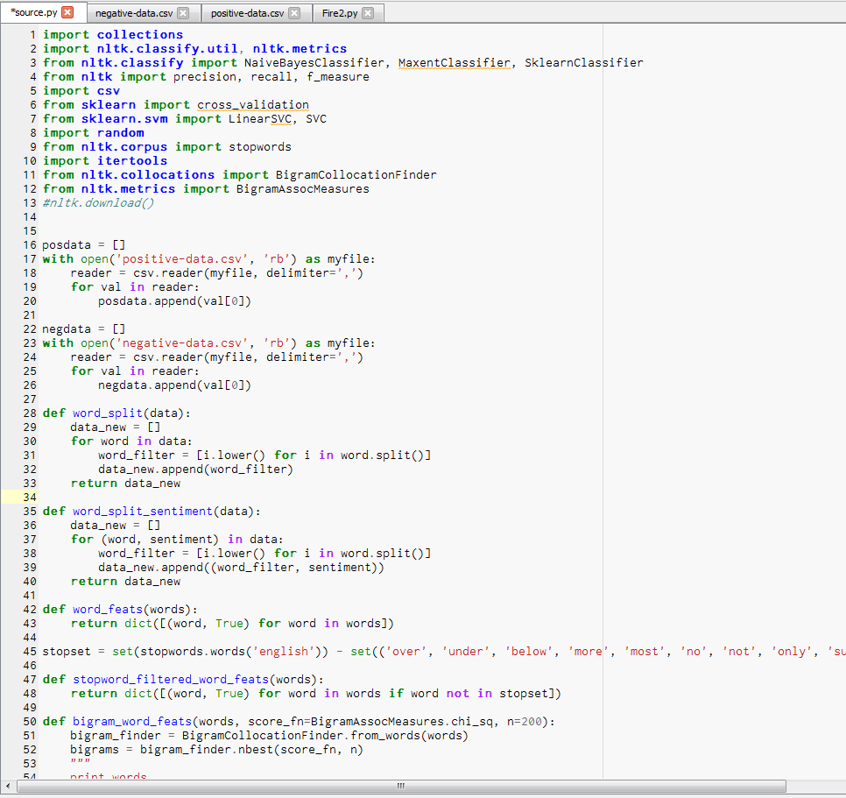

Fig. 5. Code screenshot

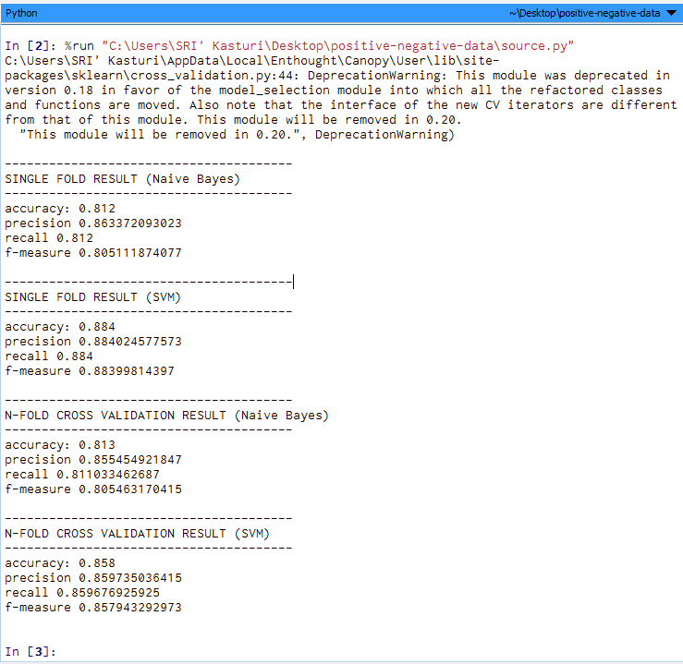
Fig. 6. Output Screenshot

  - Development Environment
Software Architecture
- Operating System-Windows 10/mac
Hardware Architecture
- Processor: Intel®Core™i3-4010U CPU @ 1.70GHz /i5 with more capacity.
- Ram: Minimum of 2GB
Development Environments/Tools
- Python 2.0/Python 3.0
- Enthought Canopy
- Natural Language Tool Kit (NLTK)
- Scipy and Numpy Libraries

- Results & Evaluation study:

The result can be improved by increasing the training dataset size. Currently, the training dataset contains of total 1000 reviews (500 positive and 500 negative). This number can be increased to see if the increment improves accuracy result. The accuracy result can also be improved by using best words and best bigrams as feature set instead of all words and all bigrams. ‘Best’ means the most frequently occurring words or bigrams. This approach of eliminating low information features (or, removing noisy data) is a kind of dimensionality. The evaluation is also done using cross-validation by giving the ‘n’ value for the folds/hybrid algorithm.
The evaluation can be done using different feature sets like all words feature set, all words feature set with stop word filter, bigram word feature set, and bigram word feature set with stop word filter.
The recognition of the emotional polarity of the sentences is conducted with very good performance by the three classifiers and this is a reason for the superior performance of the ensemble classifier. The results of the classifiers on the different data are presented in Table 2.

Table. 2. Accuracy for different classifiers:

 | SVM | NB | MAXENT
Word_feats | 82.2% | 81.3% | 80.5%
stopword_filtered_word_feats | 78.8% | 81.6% | 79.1%
bigram_word_feats | 87.7% | 82.7% | 83.0%
bigram_word_feats_stopwords | 79.8% | 79.9% | 79.9%

(* The reading of Maxent were taken from the external source.)

Table. 3. Classifier-Word_feats

 | SVM | 5 Fold-SVM | NB | 5 Fold-NB
Accuracy | 0.884 | 0.842 | 0.712 | 0.842
Precision | 0.822 | 0.8428 | 0.8088 | 0.8428
Recall | 0.884 | 0.8411 | 0.712 | 0.8411
F-measure | 0.839 | 0.8421 | 0.6875 | 0.8412

Table 4. Classifier-stopword_filtered_word_feats

 | SVM | 5 Fold-SVM | NB | 5 Fold-NB
Accuracy | 0.876 | 0.849 | 0.78 | 0.803
Precision | 0.8766 | 0.8501 | 0.8413 | 0.8456
Recall | 0.876 | 0.8497 | 0.78 | 0.8024
F-measure | 0.8759 | 0.8485 | 0.7696 | 0.7953

Table 5. Classifier-bigram_word_feats

 | SVM | 5 Fold-SVM | NB | 5 Fold-NB
Accuracy | 0.884 | 0.858 | 0.812 | 0.813
Precision | 0.885 | 0.859 | 0.863 | 0.855
Recall | 0.8840230 | 0.859 | 0.812 | 0.811
F-measure | 0.8839 | 0.857 | 0.805 | 0.805

Table 6. Classifier-bigram_word_feats_stopwords

 | SVM | 5 Fold-SVM | NB | 5 Fold-NB
Accuracy | 0.872 | 0.866 | 0.864 | 0.865
Precision | 0.8723 | 0.8659 | 0.893 | 0.867
Recall | 0.872 | 0.8657 | 0.864 | 0.8643
F-measure | 0.871 | 0.8657 | 0.861 | 0.8625

The best performance of a sole classifier is achieved by the SVM classifier, which accuracy and precision are better than those of the Naïve Bayes in all the experiments. The Naïve Bayes classifier performance is slightly lower than that of naïve Bayes. It goes better in headline and article sentences, but its performance decreases in texts almost in the same degree as SVM.

- Conclusions and future work

In this paper, an ensemble classifier system for the emotion analysis of textual data is presented. It is based on three main classifiers, a Naïve Bayes learner, a maximum entropy and SVM. These learners were trained on ISEAR and YELP affective text datasets the natural language toolkit performs structure, specifies explanation dependencies and determines the way that words are connected. By this experiment we are able to calculate the polarity of the sentimental words using which we are able to calculate the metrics for the text classification. We are to produce the outputs for the SVM and Naïve Bayes successfully. Maximum entropy algorithm was unable to sync with Natural Language Toolkit due to which we are unable to produce the metrics.

Right now we have worked with only the very simplest unigram models; we can improve those models by adding extra information like closeness of the word with a negation word. We could specify a window prior to the word (a window could for example be of 2 or 3 words) under consideration and the effect of negation may be incorporated into the model if it lies within that window.

In addition to this we can attempt to model human confidence in our classifier. If we have 5 human labellers labeling each text, we can plot the text in the 2-dimensional objectivity / subjectivity and positivity / negativity plane while differentiating between texts in which all 5 labels agree, only 4 agree, only 3 agree or no majority vote is reached. In addition to this can be develop the application without using the Natural Language Toolkit and Bag-of-Words.

- Acknowledgments
I thank Prof. Sheela Ramanna for her helpful and insightful discussions, suggestions regarding this project.
The coding idea of this application development in python was inspired from the Sentiment analysis using Naïve Bayes. In which sentiment analysis was only developed for NB and we have integrated this code with SVM and some part of Maxent.
Source: http://streamhacker.com/2010/05/17/text-classification-sentiment-analysis-precision-recall/
Part of this coding work was supported by one of my friend Kishore and Surya.

References
- Isidoros Perikos n, Ioannis Hatzilygeroudis: Recognizing emotions in text using ensemble of classifiers . Engineering Applications of Artificial Intelligence 51 (2016) 191–201
- Taner Danisman, Adil Alpkocak .:Feeler: Emotion Classification of Text Using Vector Space Model In AISB 2008 Convention, Communication, Interaction and Social Intelligence, Vol. vol. 2 (April 2008)
- Durgesh Patel 1, Sakshi Saxena 2,: Sentiment Analysis using Maximum Entropy Algorithm in Big Data DOI:10.15680/IJIRSET.2016.0505246
- Vishal A. Kharde, S.S. Sonawane.: Sentiment Analysis of Twitter Data: A Survey of Techniques.International Journal of Computer Applications (0975 – 8887) Volume 139 – No.11, April 2016
- Snehal L. Rathod, Sachin N.Deshmukh.: Sentiment Analysis Using SVM and Maximum Entropy. International Research Journal of Engineering and Technology (IRJET) e-ISSN: 2395 -0056 Volume: 03 Issue: 08 | Aug-2016
- John La_ertyy, Kamal Nigamy.: Using Maximum Entropy for Text Classi_cation. 2010 IEEE ICE 10.1109/ICICISYS.2010.5658639
- A.Pak and P. Paroubek. „Twitter as a Corpus for Sentiment Analysis and Opinion Mining". In Proceedings of the Seventh Conference on International Language Resources and Evaluation, 2010, pp.1320-1326

